VPN Tunnelling Lab
Random Notes
- Virtual private network (VPN) – a secure connection that encrypts your internet traffic and routes it through a remote server, effectively masking your IP address and protecting your online privacy.
Components:
- VPN Client- software or device that initiates a secure connection to a VPN server. Encrypts outgoing data and sends it through the VPN tunnel.
- VPN Server- central system that manages VPN connections, authenticates users, and encrypts/decrypts data. Acts as a gateway
- Host in Private network- any device that the VPN client accesses after connecting to the VPN server.
- Tunnelling - process of encapsulating data inside another data packet to securely transmit it over the internet. It ensures that third parties, like hackers or ISPs, cannot intercept or modify your traffic. Types: OpenVPN, WireGuard
- Encryption - converts readable data (plaintext) into scrambled data (ciphertext) that can only be read by someone with the correct decryption key.
- TUN/TAP - virtual interfaces used in VPNs to create a secure communication channel.
TUN – Network Tunnel (Network Layer- layer 3) handles Ip packets – routing traffic
TAP - Network Tap (Data Link Layer- layer 2) handles ethernet frames – connect remote devices to the same virtual LAN
- Routing in VPNs – determine how packets travel through the tunnel to their destination
Types: full tunnelling, split tunnelling, policy-based routing
Methods: Static, Dynamic routing
- Gateway – network device/ software that acts as a bridge between different networks managing how data is transferred between them (Network Layer -handle IP traffic routing)
- Private network - restricted to a specific group of devices and users, preventing unauthorized access from the public internet.
- Public Key Infrastructure (PKI) - framework that manages public-key encryption and digital certificates. It enables secure communication over insecure networks
- Transport Layer Security (TLS) - cryptographic protocol that provides secure communication over a network (e.g., HTTPS). It relies on PKI for identity verification and key exchange.

Task 1: Network Setup
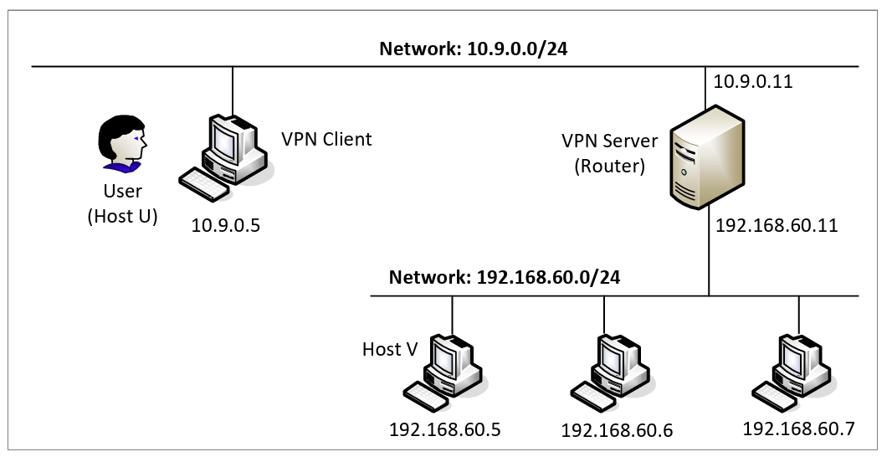
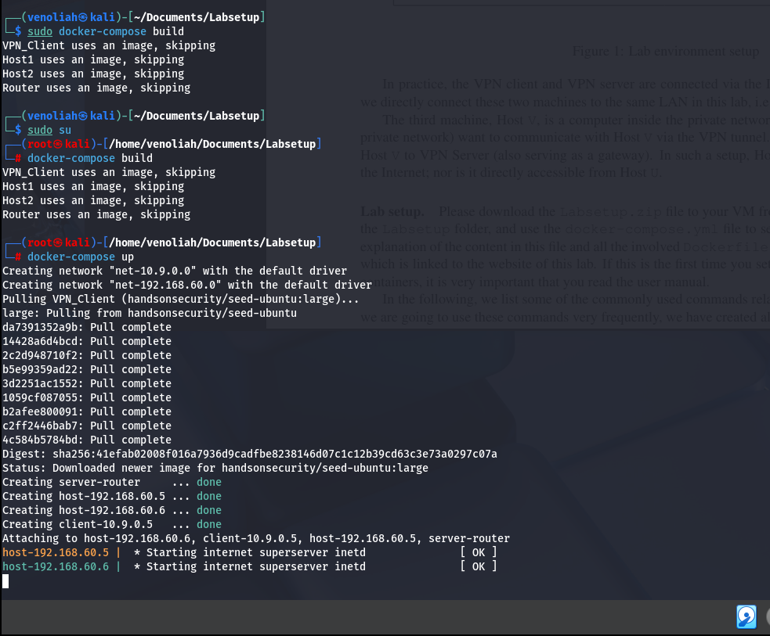
Based on the image above the containers working appropriately and are running in the background thus open a new tab to create a shell on the containers to run commands.
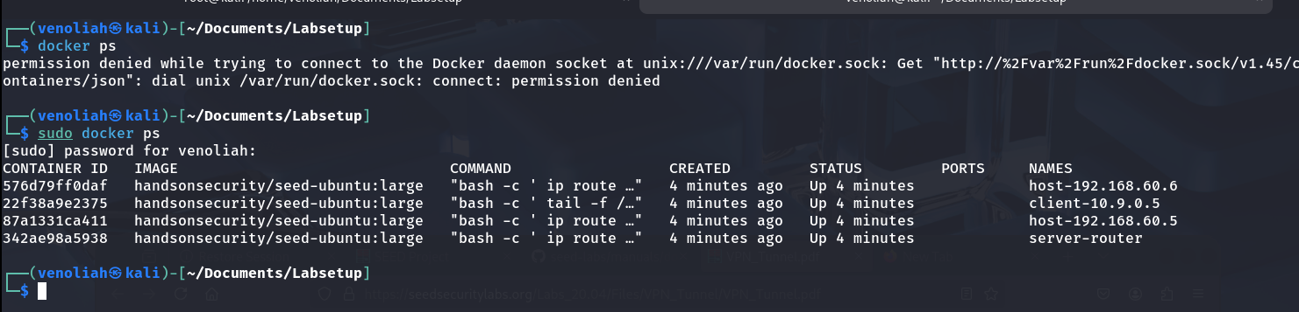
Error: The error (Permission denied) indicated is due to lack of root privileges
The output shows the containers are up thus we need to run shells inside them.
- Shell = a program that acts as an interface between the user and the operating system (OS) i.e. windows uses PowerShell, Linux uses Bash
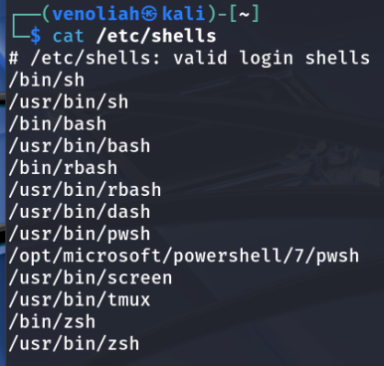
cat /etc/shells command used to list the available shells installed
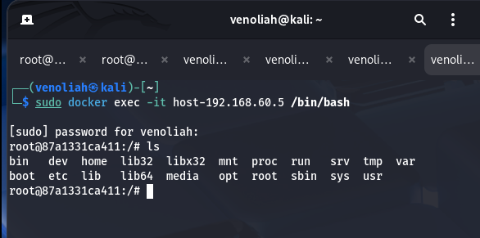
sudo docker exec -it server-router /bin/bash
sudo docker exec -it client-10.9.0.5 /bin/bash
sudo docker exec -it host-192.168.60.5 /bin/bash

Packet sniffing (network sniffing)- this is the process where data packets transmitted over a network are intercepted and analyzed
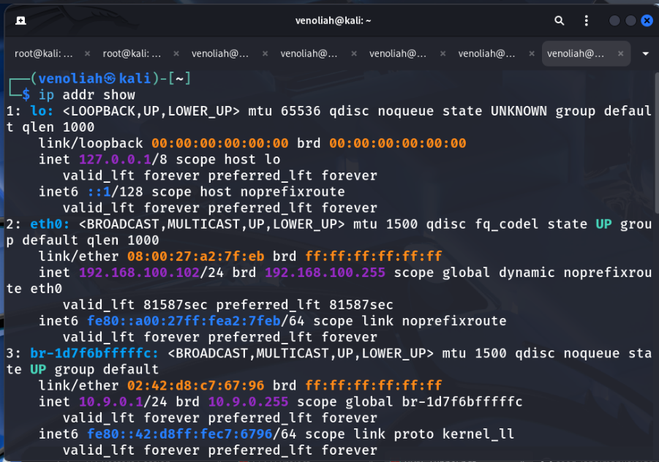
Use ip addr show command to list all interfaces on the vm
Tests: (done on the individual containers using tcpdump)
- tcpdump = command-line packet analyzer used to capture and display network traffic (TCP, UDP, and ICMP)
- ping = test reachability of host by sending ICMP (Internet Control Message Protocol) echo request packets
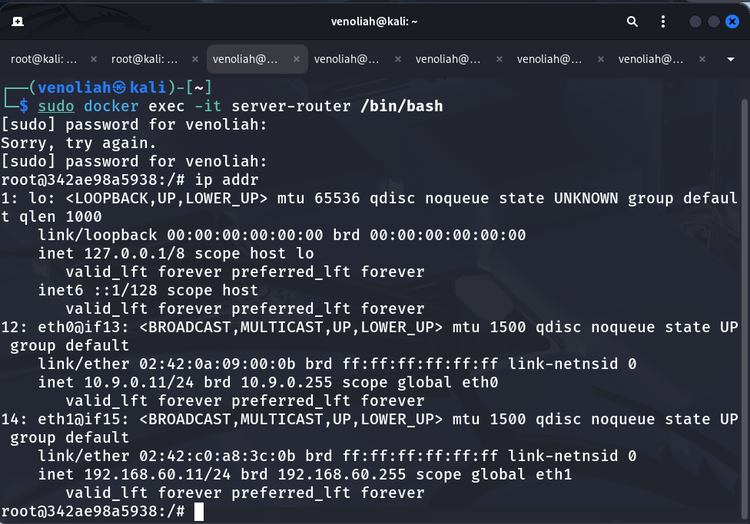
• Host U can communicate with VPN Server.
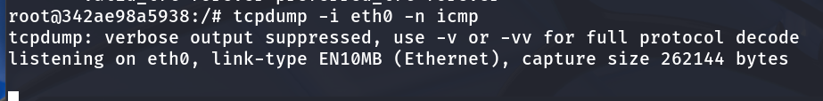
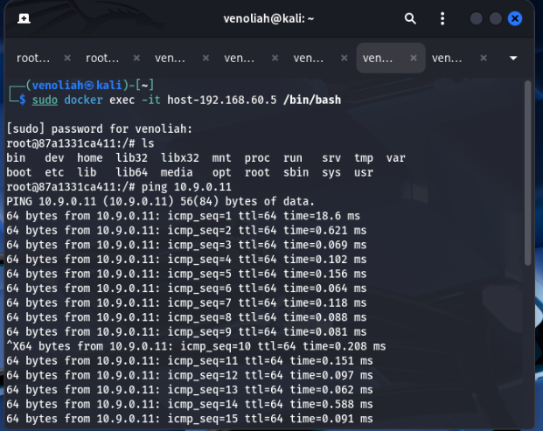

• VPN Server can communicate with Host V.
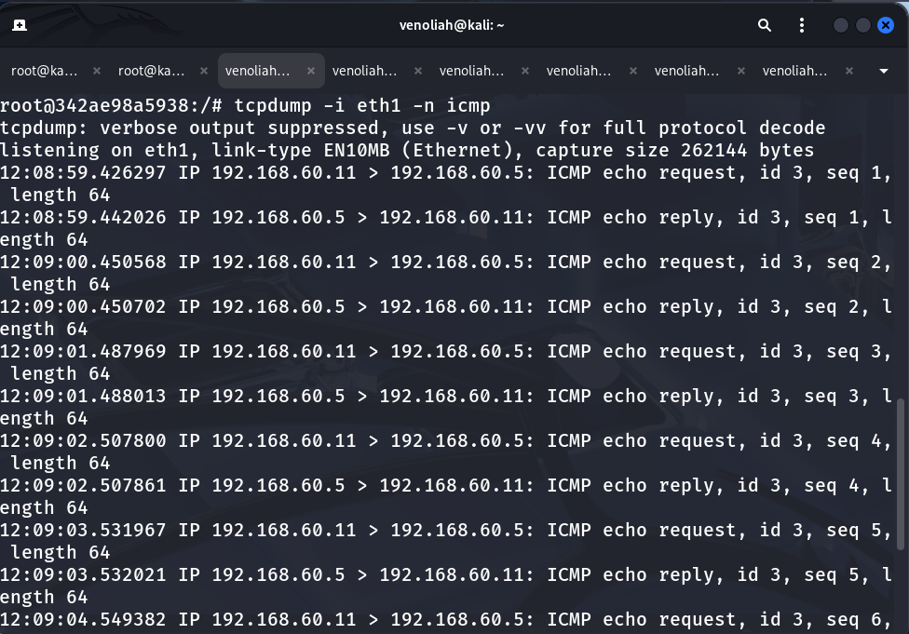
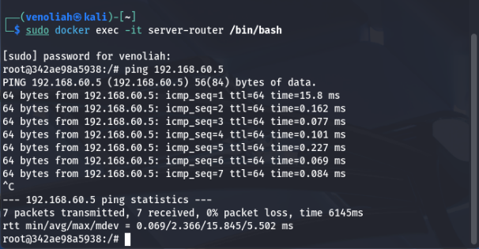
• Host U should not be able to communicate with Host V.
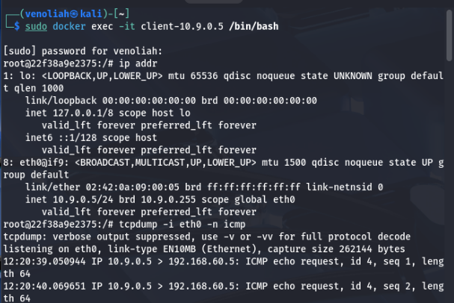
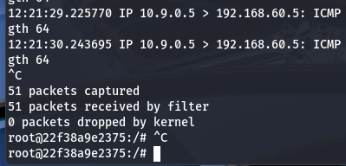
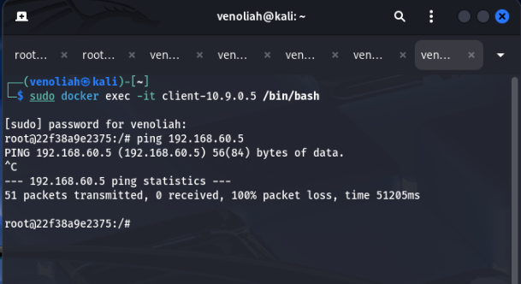
Wireshark – for packet sniffing (it’s a protocol analyzer)
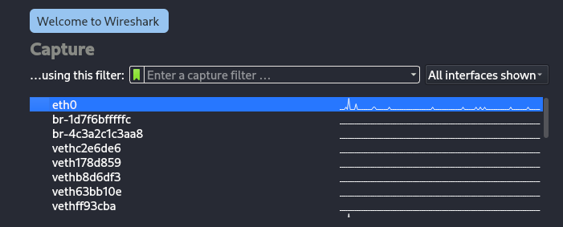
The above image shows the list of interfaces running
• Host U can communicate with VPN Server.
Select br-1d7f6bfffffc which matches the subnet for host U then apply the icmp filter and start capture
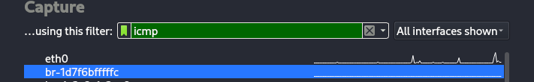
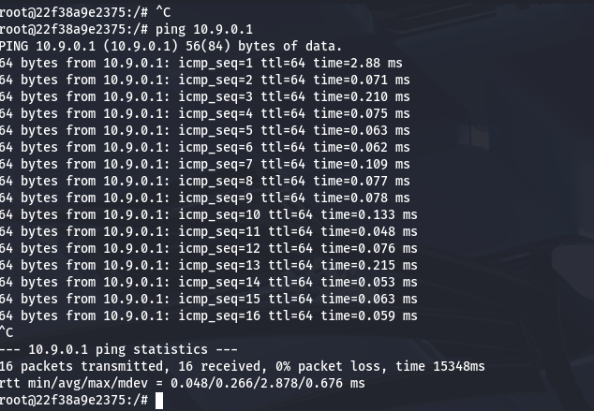
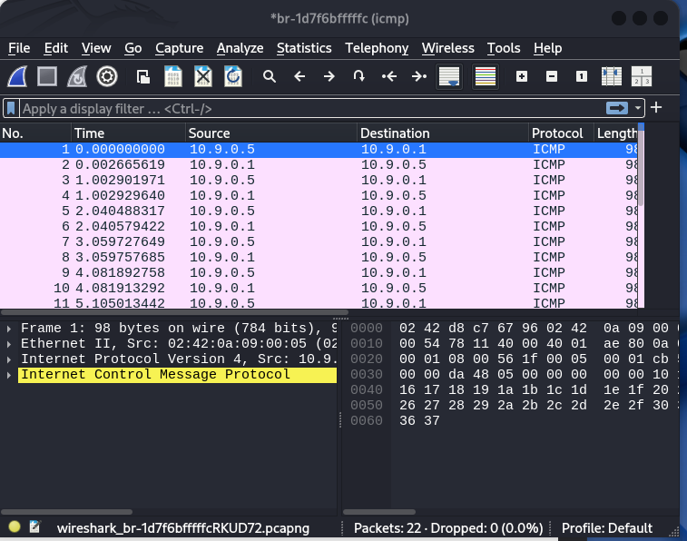

Task 2: Create and Configure TUN Interface
TUN (network TUNnel) - a network interface within the kernel enabling us to form virtual connections in the operating system.
- Operates on layer 3 of the OSI model (Network layer), handling the transmission and reception of IP packets
- lacks the capability of bridging different LANs as opposed to TAP
TAP (network TAP) – Handles Ethernet frames (e.g., ARP, IP, etc.)
- Operates on layer 2 of the OSI model (Data-link layer) to transport non-IP based traffic and if you want to bridge
TUN/TAP devices are only used by certain VPN protocols (such as OpenVPN and WireGuard) and not others (such as IKEv2).

